**Mantra/Tagline**

A single sentence description of the game that you will use to guide design decisions. *Example: an educational infinite running game that tests your mental reflexes.*

|  |
| --- |
| A 2d platformer run and gun game with a visual identity of showing current memes of our society |

**Design Pillars**

List up to 3 words/phrases that convey the feeling or emotion you want the player to experience. *Example: Fast. Cerebral. Smart.*

|  |  |  |
| --- | --- | --- |
| progression | fast | simple |

**Story/Gameplay Summary**

List what the game is from a gameplay and/or story perspective. *Example: This game places the player into an infinite runner where they have to answer progressively harder trivia questions about geography in order to get power ups and stay alive.*

|  |
| --- |
| The game puts the player in the perspective of Olivia Kane where she battle the forces of the boomers and their current rule of society using the tools millinials know best |

**Storyboard**

What’s the arc of the gameplay? See this [introduction to storyboards](https://www.nngroup.com/articles/storyboards-visualize-ideas/) for user experience design. Use their [template](https://media.nngroup.com/media/articles/attachments/Storyboard-Template.pdf), or something like it with frames that have captions. See some game storyboard examples: [VR game](https://www.artstation.com/artwork/nxzXr), [robo game](https://sites.google.com/site/videogamedesigntsanh/home/storyboard), [platforming game](https://www.storyboardthat.com/storyboards/soradora/storyboard--penguin-jump). Your storyboard should have at least six frames that explain the key features of your game. Think about the progression all the way from title screen to the win/end screen.

|  |
| --- |
| [Insert sketches here] |

**Feature List**

List all the features that you want to include in your game. Don’t worry about implementation - it’s okay to list a feature you don’t know how to make. Everything is a feature - from collectables, to player controls to showing visual feedback when a character is hit, to story voice-overs triggered when you enter a room, to a HUD, to the player’s footstep sounds, etc. If you’ve got less than six features, you are very likely missing things or your features are too big (e.g. “platforming” is not a feature, it’s multiple - player movement controller, level design, player animation, etc.).

|  |  |
| --- | --- |
| * Platformer * HUD * cutscenes * Level progression * Unlockable weapons | * powerups * ... * ... * ... * ... |

**Prototype**

Describe what you’ll need to build for your prototype of the core mechanic of your game. What’s the least you can build to test your idea? *For the infinite runner quiz game, that would mean that, at the bare minimum, my prototype should feature a player object moving forward with obstacles spawning in the way and a way to track when the player hits an obstacle. I would use simple Unity primitives for the player (gray sphere) and obstacles (red boxes).*

|  |
| --- |
| Basic platformer with enemy spawning with shooting and basic AI followers |

**References**

Link to at least three links to other pieces of media - books, designs, other games, etc. - that have something similar to what you are trying to accomplish and explain which element you are interested in. It could have similar gameplay elements, a related story motif or an aesthetic you want to remix.

|  |
| --- |
| Metal slug and cuphead for gameplay mechanics  Tracer from overwatch for art design for character  Zombieville for design and simple level progress |

**Target Audience & Platform**

Who is the target audience for the game (e.g. age, interests, type of games they play, when they play)? How does that experience it (e.g. mobile, browser, AR/VR, desktop with keyboard, console with controller site-specific, etc.)? “Everybody” is not a target audience. *For example, for an educational game to teach geography, the target audience might be high schoolers who like to play quick and rewarding casual games, and it will be played in classrooms on PCs with a mouse and keyboard.*

|  |
| --- |
| Pc and mobile platorm  Interests for casual gamers of all ages  Simple and made for everyone |

**Asset Research**

This is primarily a scripting class, so the focus is not on creating your own assets. Look through the free resources to find assets that you are considering for your project. Link them below. At minimum, you should have both visual assets and sound assets linked below.

|  |
| --- |
| Assets wise will create pixel art for characters and animations, not too hard  Background art may use metal slug for inspiration  Sounds for now incomptech for background music and SFX |

A 2d platformer run and gun game with a visual identity of showing current memes of our society.

The game puts the player in the perspective of Olivia Kane where she battles the forces of the boomers and their current rule of society using the tools millennials know best.

The game puts the player in the perspective of Olivia Kane where she battles the forces of the boomers and their current rule of society using the tools millennials know best.

Even though this is just supposed to be a basic game design document, this a independent side project that I’m currently working on.

Some mechanics include:

* Platformer combat
* HUD
* cutscenes
* Level progression
* Unlockable weapons

Inspirations for the game:

* Megaman and Cuphead for gameplay mechanics
* 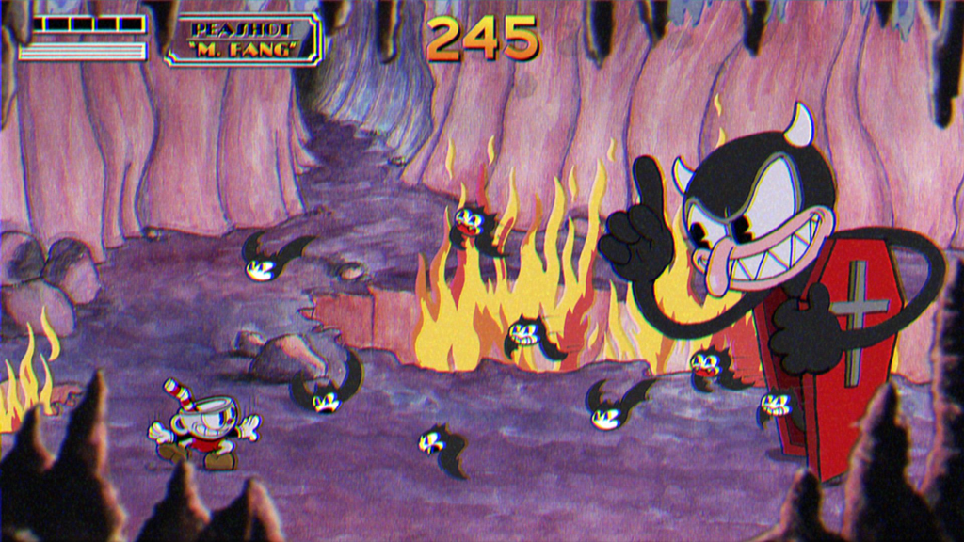
* Tracer from overwatch for art design for character
* 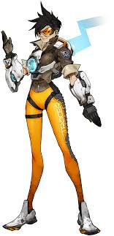
* Zombie Ville for design and simple level progress
* 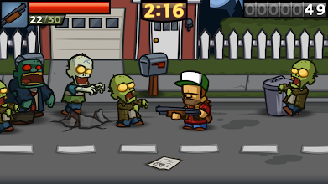

Color Palette

* For PC Olivia Kane

Storyboard

* Run Animation

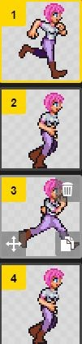

Data/Flowchart

Current animation chart

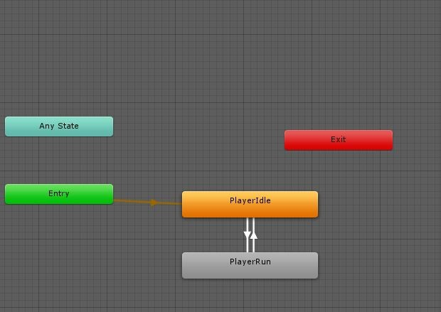

Timeline

* Tutorial Level

Spawn-WASD UI popup-walk-platform spawn-jumpUI popup-jump-running jump

* Combat

EnemySpawn-CombatTutorialUIPopUp-Punch-enemydeath-powerupdrop

* Powerup

Spawn-pickup-if1stUIpopup-grant pc powerup(health, bullets, etc)